Name: Priyanshu Tripathi
Roll number: 12022005

Subject: Java Programming
Code: CSPC-23
Assignment 1
INDEX
S. No. | Content | Page No.
1 | Multiply digits | 3
2 | Minutes to years | 4
3 | BMI Calculator | 5
4 | Interest Rate | 6
5 | Check if multiple | 7
6 | Convert Base | 8

1. Multiply digits
Write a program that reads an integer between 0 and 1000 and multiplies all the digits in the integer. For example, if an integer is 932, the multiplication of all its digits is 54.
import java.util.Scanner;

public class foobar {
public static void main(String[] args) {
Scanner sc = new Scanner(System.in);

System.out.print("Enter the number --> ");
int num = sc.nextInt();
int result = multiply(num);

System.out.println("Multiplication of all digits --> " + result);
}

public static int multiply(int num) {
int result = 1;
while(num > 0) {
result *= num % 10;
num /= 10;
}
return result;
}
}
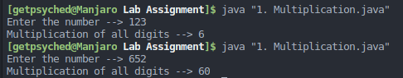

2. Minutes to years
Write a program that prompts the user to enter the minutes (e.g., 1 billion), and displays the number of years and remaining days for the minutes. For simplicity, assume that a year has 365 days.
import java.util.Scanner;

public class foorbar {
public static void main(String[] args) {
Scanner sc = new Scanner(System.in);

System.out.print("Enter time in minutes --> ");
int min = sc.nextInt();
int years = min / (365*24*60);

int days = min - (years * 365*24*60);
days /= 24 * 60;

System.out.println(String.format("%s years and %s days", years, days));
}
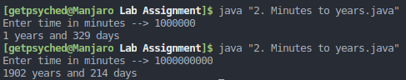
}

3. BMI Calculator
Body Mass Index (BMI) is a measure of health on weight. It can be calculated by taking your weight in kilograms and dividing, by the square of your height in meters. Write a program that prompts the user to enter a weight in pounds and height in inches and displays the BMI. Note one pound is 0.45359237 kilograms and one inch is 0.0254 meters.
import java.util.Scanner;

public class foobar {
public static void main(String[] args) {
Scanner sc = new Scanner(System.in);

System.out.print("Enter weight --> ");
double weight = sc.nextDouble();
System.out.print("Enter height --> ");
double height = sc.nextDouble();

System.out.println(BMI(weight, height));
}

public static String BMI(double weight, double height) {
weight *= 0.45359237;
height *= 0.0254;
double bmi = weight / (height*height);

String str = "";

if (bmi < 18.5) str = "Underweight";
else if (bmi >= 18.5 && bmi < 25) str = "Healthy";
else if (bmi > 25 && bmi < 30) str = "Overweight";
else if (bmi > 30) str = "Obese";

return String.format("BMI --> %.2f (%s)", bmi, str);
}
}
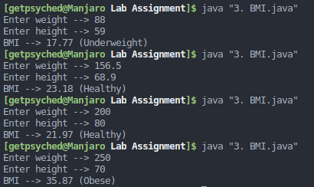

4. Interest Rate
If you know the balance and the annual percentage interest rate, you can compute the interest on the next monthly payment using the following formula:
interest = balance * (annualInterestRate/1200)
Write a program that reads the balance and the annual percentage interest rate and displays the interest for the next month.
import java.util.Scanner;

public class foobar {
public static void main(String[] args) {
Scanner sc = new Scanner(System.in);

System.out.print("Enter balance --> ");
double bal = sc.nextDouble();
System.out.print("Enter interest rate --> ");
double rate = sc.nextDouble();

System.out.println(String.format("Next month's interest --> %.2f", bal * (rate/1200)));
}
}
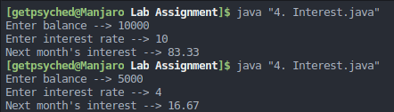

5. Check if multiple
Write an application that reads two integers, determines whether the first is a multiple of the second and prints the result. [Hint: Use the remainder operator]
import java.util.Scanner;

public class foobar {
public static void main(String[] args) {
Scanner sc = new Scanner(System.in);

System.out.print("Enter first number --> ");
int num1 = sc.nextInt();
System.out.print("Enter second number --> ");
int num2 = sc.nextInt();

if (num1 % num2 == 0)
System.out.println("The first number is a multiple of second");
else
System.out.println("The first number is not a multiple of second");
}
}
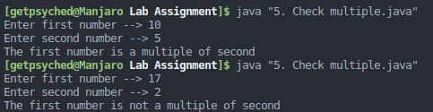

6. Convert base
Write a program that reads an integer and prints it in binary, octal, and hexadecimal.

import java.util.Scanner;

public class foobar {
public static void main(String[] args) {
Scanner sc = new Scanner(System.in);

System.out.print("Enter the number --> ");
int num = sc.nextInt();

System.out.println("Binary --> " + Integer.toBinaryString(num));
System.out.println("Octal --> " + Integer.toOctalString(num));
System.out.println("Hexadecimal --> " + Integer.toHexString(num));
}
}
